



JAVA PROGRAMMING
(340)

NATIONAL 2021

PRODUCTION PORTION:

Delimited Portfolio File (350 points)

TOTAL POINTS (350 points)

Test Time: 90 minutes

You will have ninety (90) minutes to complete your work.

Your name and/or school name should not appear on work you submit for grading.

- Create a folder on the flash drive provided using your contestant number as the name of the folder.
- Copy your entire solution/project into this folder.
- Submit your entire solution/project so that the graders may open your project to review the source code.
- Ensure that the files required to run your program are present and will execute on the flash drive provided.

*Note that the flash drive letter may not be the same when the program is graded as it was when you created the program.

*It is recommended that you use relative paths rather than absolute paths to ensure that the program will run regardless of the flash drive letter.

The graders will not compile or alter your source code to correct for this.
Submissions that do not contain source code will not be graded.

Assumptions to make when taking this assessment:

- The text file imported into the driver program will be error free and all of the data values will be in the correct order. NOTE: the product type symbol can be a either upper or lowercase.
- The input file will contain only ASCII characters.
- A test input file will be available and named, "portfolioText.txt.”
- The Stocks.class file needs to be in your project folder and will be used to help with the solution. This class will be used to construct Stock objects in the Portfolio.
- The InvestmentProducts java file needs to be in the project and will be used to help create a child class called ETF.

Development Standards:

- Your Code must use a consistent variable naming convention.
- All methods (if any) must be documented with comments explaining the purpose of the method, the input parameters (if any), and the output (if any).
- If you create a class, then you must use Javadoc comments.

Note to Graders: The contestants have been given a file named portfolioText.txt. You must first delete that file from the contestant’s flash drive and run the program for Test case #1. This should result in a message that the file was not found. Then replace the file on their flash drive with the grader’s file with the same name and run Test case #2. You’ll run their program with a grader’s file named portfolioText.txt which will contain different data than the student file. This will produce different results than the student’s file. You must copy the grader’s portfolioText.txt file into the folder where their program runs. Listed below are the test cases and their results.

Test case #1 verifies that the program checks for the correct input file. The output wording does not need to be exact.

Text case #2 processes the correct data file name and produces output. The output wording must be exact.

Test Case #1

The text file was not found.

Test Case #2 (verify comma delimited file was processed correctly)

What do you want to do today: BUY, SELL, LIST, or END?
list
There are 3 Stocks and 3 ETF's.
Symbol: OPQ | Type: Stock | Company Name: compSTK1 | Price: 10.2 | Total Shares: 5 | Total Value: 51.0
Symbol: RST | Type: ETF | Company Name: compETF2 | Price: 29.1 | Total Shares: 10 | Total Value: 291.0
Symbol: UVW | Type: Stock | Company Name: compSTK3 | Price: 10.0 | Total Shares: 50 | Total Value: 500.0
Symbol: XYZ | Type: ETF | Company Name: compETF4 | Price: 100.0 | Total Shares: 10 | Total Value: 1000.0
Symbol: AAA | Type: ETF | Company Name: compETF5 | Price: 100.0 | Total Shares: 10 | Total Value: 1000.0
Symbol: BBB | Type: Stock | Company Name: compSTK6 | Price: 100.0 | Total Shares: 10 | Total Value: 1000.0

This is the total value of the portfolio: 3842.0
What do you want to do today: BUY, SELL, LIST, or END?

Test Case #3 (verify command entries (BUY, SELL, LIST) are handled appropriately)

What do you want to do today: BUY, SELL, LIST, or END?
buy
Which stock do you want to buy?

What do you want to do today: BUY, SELL, LIST, or END?
sell
Which stock do you want to sell?

What do you want to do today: BUY, SELL, LIST, or END?
end
Good bye

Your application will be graded on the following criteria:
Solution and Project
The project is present on the flash drive |  | 10 points
The projects main class is named StockDriver |  | 10 points
The projects helper class is named Portfolio |  | 10 points
The projects helper class is named InvestmentProducts |  | 10 points
Javadoc comments are used for new classes |  | 10 points
Program Execution
The program runs from the USB flash drive |  | 10 points
If the program does not execute, then the remaining items in this section receive a score of zero.
The program displays in the console the request to BUY, SELL,LIST, END? |  | 20 points
The program displays entire list of Stocks and ETF’s when LIST (non case sensitive) is entered into the command prompts. |  | 30 points
The program displays the correct count of stocks and ETF’s. |  | 20 points
Program forces user to correctly enter in one of the commands |  | 20 points
When BUY or SELL (non case sensitive) is entered in command prompt the program allows the user to buy or sell investment products |  | 20 points
When END (non case sensitive) is entered in command prompt the program terminates |  | 20 points
Source Code Review
The source code is properly commented
A comment containing the contestant number is present |  | 10 points
Methods and code sections are commented |  | 20 points
Portfolio class: stores Stocks and ETF’s into a generic InvestmentProducts list |  | 20 points
Portfolio Class: getCommand( ) takes user input and properly calls correct method |  | 20 points
ETF class: extends InvestmentProducts and implements all methods |  | 20 points
ETF class: overwrites toString( ) to allow printing of object |  | 10 points
StockDriver class: main( ) imports text file and uses delimeter (, ) to read file | _____ | 30 points
StockDriver class: uses a try /catch for exception handling | ____ | 10 points
StockDriver class: code can read uppercase or lowercase productType
StockDriver class: code inputs ETF and Stocks to different method calls for the portfolio | ____ | 10 points
Code uses a consistent variable naming convention | ____ | 10 points
Total Points = 350

Suggested Solution

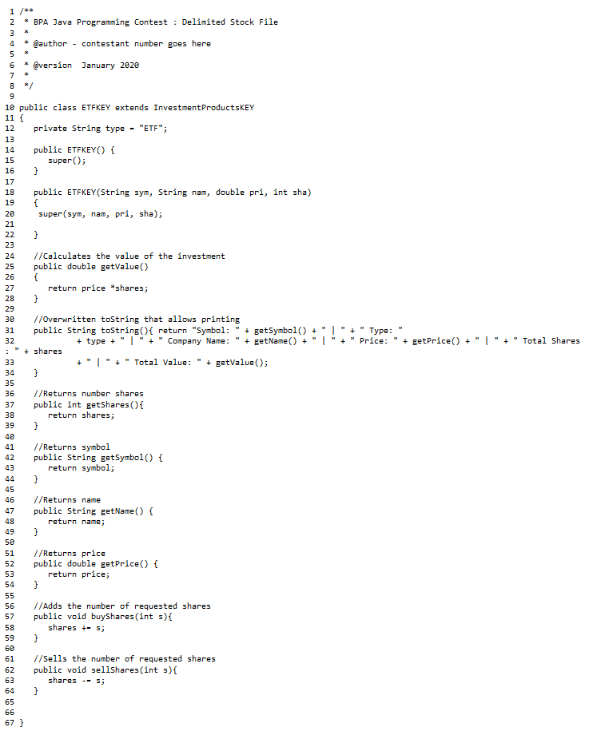

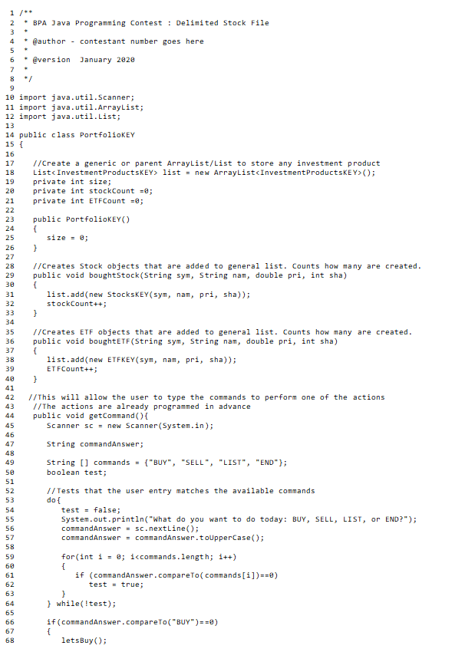
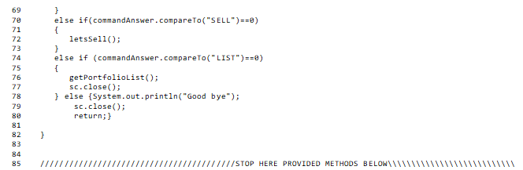
NOTE: There are methods below this line in the actual code. These helper methods were created in advance to assist the students in the creation of the program.

